CPD Questionnaire

Ayanay Psychological Accreditation

Elevated Membership
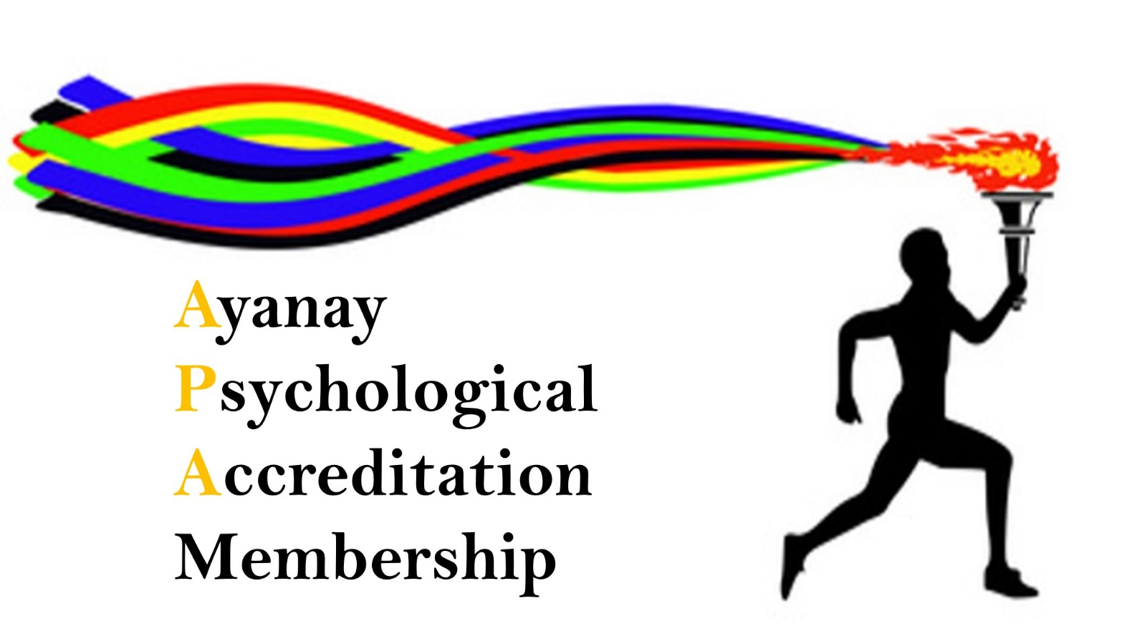
Psychological Awareness
for all

The Benefits:

No hierarchy of professionals
Client focused over financial bias
Maximum support for professionals
Elevated learning that’s relevant, responsive and required
Active member promotion
Therapeutic community development
Opportunity to become an AYANAY Facilitator
Discounted Career Professional Development
Discounted Insurance with Holistic Services Insurance
25% discount on all AYANAY Retreats*
EMERGENCY SUPERVISION
Open to all Therapeutic Professionals and those that are Psychologically aware.

APA Membership
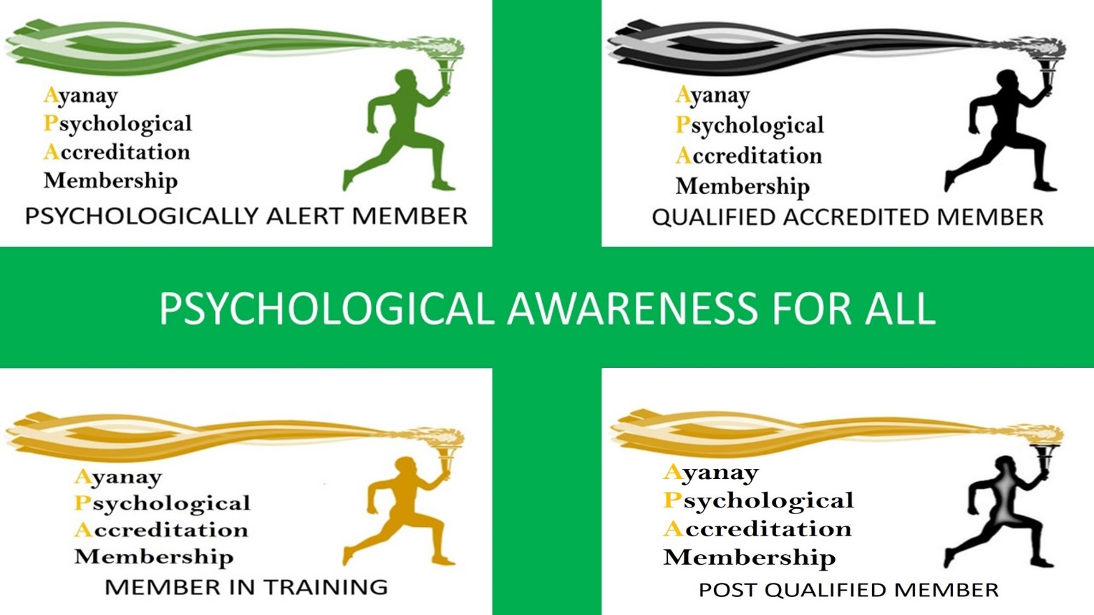
CPD Questionnaire

INTRODUCTION

This CPD Questionnaire has been put together to support all therapeutic professionals.
This questionnaire applies, ONLY to APA Video presentations on the APA Channel
That are from the ‘In Conversation With’ and ‘Featured Members’ collections.
These are all identifiable by the following images.

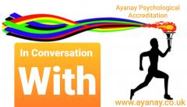

From MAY 1st 2020 This CPD package will be available to all
APA Members for free
Simple record your Membership Number on the Questionnaire and leave the payment option blank.
NON-APA Members can still benefit from this CPD package. For just £8.00
No Electronic Signatures can be processed. Please print, complete, scan and return The Questionnaire and Payment Form as appropriate. Thank you.

The Questionnaire

Name:

APA Membership Number:
Non-Members must complete the payment instruction form.

Title of the CPD Video watched:

What was the standout learning you gained from the video?

Please outline, how you can incorporate this learning into your work?

Signed: ______________________ Date:_________________ No Electronic Signatures can be processed. Please print, complete, scan and return.

Credit Card Authorisation
By completing this component of the form, you allow authorisation for payment of the specified products, goods and services by Ayanay Psychological Membership Ltd
The total to be paid is: __£8.00__
Type of Card

Visa Mastercard Amex
Card Number
Expiry Date MM YYYY
CVC
Name of Authorised Signatory: ___________________________________
Billing Address:

Signature: ______________________________________________
No Electronic Signatures can be processed. Please print, complete, scan and return.
Or if you prefer
BAC’s Transfer of full payment
I confirm payment for a total of £8.00 has been made via BAC’s Transfer to:
Ayanay Psychological Membership Ltd
Barclays Bank
Acc: 33233308
SC: 20-89-56

APA
Membership
Our Focus
Create, Increase, Provide and Elevate

Create: an effective framework for the sustainable and successful development of best practice within the therapeutic community.
Increase: the positive awareness and use of therapeutic knowledge.
Provide: the therapeutic community with an ever evolving and enhancing level of support.
Elevate: public confidence in the effectiveness and professionalism of the therapeutic community.

